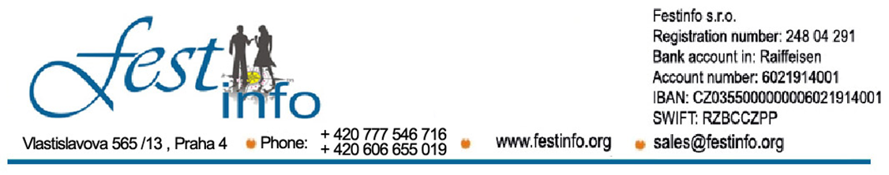

We invite you to come to the
I International Folklore Festival in Umag - Istria
from
09.05 – 12.05.2019.
Participating ensembles are from Croatia, Russia, Lithuania, Latvia, Poland, Ukraine, Greece, Turkey, Serbia, Italy, Bosnia and Herzegovina, Czech Republic, Slovakia, Bulgaria, Hungary, Romania, Armenia, Georgia, India, Indonesia, Slovenia, Macedonia…
1. DAY May 09, 2019, THURSDAY: UMAG
Upon arrival, the groups will be taken to their chosen accommodation... Informative meeting to be attended by the representatives of all groups. Getting to know the town, a tour of this beautiful coastal town, swimming and relaxation... The possibility of visiting one of the night clubs. Overnight accommodation.
2. DAY May 10, 2019, FRIDAY: UMAG - ITALY AND SLOVENIA (TRIESTE - PIRAN) - UMAG
Optional excursion to Slovenia and Italy, and the two beautiful cities of Trieste and Piran: Trieste. Trieste is a harmonious blend of Roman heritage, medieval and new century architecture. A city that has been elevated to a very high level as a result of it having been a very important Habsburg port: Miramare Castle’s fairytale-like facade, the Canale Grande, the Serbian Orthodox Saint Spyridon Church, Corso Italia, the Roman Theater, Piazza della Liberta. Leisure time and lunch, pastry shops, a walk along the seashore or shopping. Departure for Slovenia and a visit to the city of Piran, the most beautiful along the Slovenian coastline: the entire old town is a labyrinth of streets, with a layout unchanged since the Middle Ages, while the main town square, only steps from the sea, honors the famous composer Tartini who lived in this city. After a short tour, leisure time until departure for Croatia and Umag. The possibility of visiting one of the Discotheques in Umag . Overnight accommodation.
3. DAY May 11, 2019, SATURDAY – DAY OF THE FESTIVAL
Preparations of folklore Ensembles for the I International Folklore Festival in Umag. Parade through the city and the ensembles arrival to the main town square where the performance will take place (in case of poor weather conditions, the performances will take place indoors).
The opening of the “1st International Folklore Festival in Umag - Umag 2019” and performances from the Cultural and Artistic Societies !!!
After the performances, there is the possibility for all societies to go for a Friendly night out at one of the Discotheques in Umag . Overnight accommodation.
May 12, 2019 UMAG - THE PEARLS OF ISTRIA (PULA - ROVINJ)
Optional excursion of the most important cites in Istria: Rovinj and Pula. Arrival at the seaside town of Rovinj. Upon arrival, a tour of the old town, located at the foot of the Church of St. Euphemia. Leisure time. The tour continues to Pula, the largest city in Istria County, located in the southwestern part of the Istrian peninsula in a well-protected bay. The city has a long tradition of wine making, fishing, shipbuilding and tourism, while at the same time being a transit port. Pula has been the administrative center of Istria since the Roman times and even today you can find proof of this age in the Triumphal Arch of the Sergi, better known as the Golden Gate, the Temple of Augustus, mosaics, and before all else, the symbol of the city, the Colosseum (the Pula Arena). Leisure time for walking along the water and down city streets, lunch and other activities. Leaving for the place of departure with a promise of meeting up next year!!!
Price of registration fee is :
Apartmants Polynezia Plava Laguna *** 55 euro
Apartmants Sol Katoro Plava Laguna **** 65 euro
Hotel Sol Garden Istria **** 135 euro
Residence Sol Garden Istria ****125 euro
The arrangement price included:
- Accommodation is in Umag at Apartament village Polynesia Plava Laguna *** ( in 1/3;1/4 and 1/5 Apartments ) and Sol Katoro ****( in 1/4 and 1/5 Apartmants) - price is per person for 3 nights ( supplement for 1/2 Apartmants is 10 e per person per night ), and as well Accommodation is at Hotels with 4 star like Hotel Sol Garden Istría **** and Residence Sol Garden Istría **** - price is for 3 nights with half board ( both meals are on Buffet base )
- Diplomas, Plaquas and presents
- Invitation letter
- Organizational expences
- Free place on every 25 th member
The arrangement price doesn“t included:
- Supplement for half board is 14 e per person ( both meals are on Buffet base )
- Supplement for brekfast is 6 e per person ( breakfast is on Buffet base )
- Facultative tours ( excursion to Trieste and Piran 15 € , the Pearls of Istria – Pula and i Rovinj 10 € )
- Insuriance
ADDITIONAL INFORMATION: + 381 60 16 46 500; + 420 777 546 716
thru Application on our web page : www.festinfo.org or on email: prodaja@festinfo.org
Note: all ensembles must provide their own music, leading orchestar or music CD s.
Each ensemble is obligated to set performance in duartion of 10 – 15 minutes.
NUMBER OF SEATS IS LIMITED!!!!!!!

