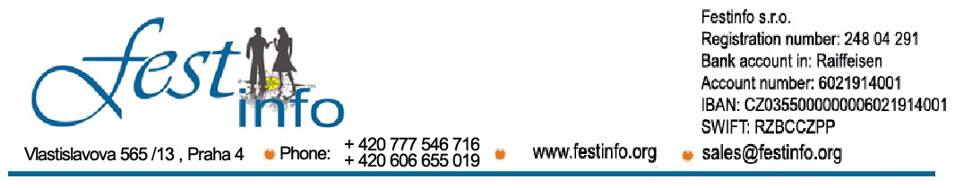

We invite you to the XIV. International Festival of Folklore in Spain -“Festival Internacional De Folclore Lloret De Mar 2025”
24.06 – 28.06.2025.
www.lloretguide.com
24th June -In morning hours arrival to the most famous tourist centre in Costa Brava-Lioret de Mar, which is 65 kilometres from Barcelona. Hotel accommodation. Lunch. Info-meeting group representer. Afternoon relaxing. Sightseeing of town, walks, and going to a performing place, town square... Facultative going out to a discoteque. Dinner. Overnight stay.
25th June – Breakfast. After breakfast possible going to tour Barcelona. Lunch (lunch packet) for those who go to Barcelona. After arriving to Barcelona follows sightseeing of Gaudi’s Barcelona, church commited to Sagrada Familia), Guel Park and well-known house of Batila and Milo. After tour of Gaudi’s works follows a walk along the main street of Barcelona, Ramblom, and than Gothic square and tour of Barcelon cathedral, Parliament, Picaso’s museum…After that free time for walks, sightseeing of Barcelona. Leaving to Lloret de Mar. Preparing for Festival :
Defile through the city of all societies and leaving to main town square where the performance is predicted. (in case of bad weather performance is going to be in a confined space).
Opening”XIV Festival Espana 2025” and performance of cultural-art societies!!!
After the performance possible facultative leaving of whole societies to Diskoteque or Flamenco club. Dinner. Overnight stay.
26 ^{th} June - Breakfast. After breakfast possible visit of Aqua park or leaving to the beach…swimming, water sports…Lunch.
Dinner.Possible facultative leaving of whole societies to Diskoteque or Flamenco club. Overnight stay.
27 ^{th} June - Breakfast. After breakfast, facultative possible going to Barcelona and second tour of town: visit to the museum and the most famous and the most beatufil stadion with possibility of buying souvenirs with inicials of FC Barcelona…After tour of Nou camp, leaving toa Monjuik hill and visiting of Olymphic comlex (royal stadion, Calatravin tower, National library)…possible tour
to famous aquarium of Barcelona… Free time for sightseeing…Return to Lioret de Mar. Lunch. (Lunch packet for those who go to Barcelona). Dinner.
Perfomance preparation.
Second night of Festival Espana 2025 !!! Perform of cultural-art societies!!!
Facultative going out to Discoteque or Flamenco show. Overnight stay.

28 ^{th} June - Breakfast. After breakfast, unfortunately, leaving of Lioret de Mar and going to France with occasional breaks…At arriving to Kan follows the tour and sightseeing of movie palace, golden stairs, fortress…After Kan sightseeing of Nice: English promenade, Nike monument, Opera, Shato, monument for the dead, Garibaldi’s house…

Price of registration fee is

215 € ( for the accommodation at 3 star Hotels )

235 € (for the accommodation at 4 star Hotels )
The arrangment price includes:
- Four days in Loret de Mar at hotel”s like Gran Garbi****, Garbi Mar****, Montevista***, Xaine Park****, Sun Village ****, Garbi Park ***,Vila Garbi ***, Casino hotel***, Clipper**, Caribe ***, Golden Sand ***, Samba ***, Hotel Evenia Olympic Resort ****, Fenals Mar ***, Casablanca ***, Copacabana ***, Hotel Mariner **** … (breakfast, lunch and dinner – BUFFET SERVICE in 1/3 and 1/4 rooms ), supplement for 1/2 rooms is 8 e per person per night
- Performance on “Festival Espana 2025” (1-3 performances) which will be performed in Lioret de Mar, Defile of all societies on town square, representing of societies…
- Degrees and Silver plaqas after performance
- Inviting letter
- Additional seat on every twenty fifth member
The arrangment price doesn't include:
- Tourist tax at Hotels in Lloret de Mar from 0.50 € too 1.5 € per person per day
- we can arange overnight staying in way to Lloret de Mar ( in hotels near Florence, Venice, Vicenza... – depend of hotel from 35 € - 45 e for night with breacfast ) and in way back
- Additional day cost from 50 € per a person in hotel Lioret de Mar (breakfast, lunch, dinner) in 1/3 and 1/4 rooms, price depends of day of additional overnight stay and Hotel price in that moment
- Facultative tours ( Barcelona from 25 €, Flamenco show from 30 €, Camp Nou from 30 € , Aquarium Barcelona from 25 €, Water world from 25 € … ) – all prices depends of number of persons in group and ticket prices in moment of excursions and it can be changed
- insurance
ADDITIONAL INFORMATION: +381 60 16 46 500
or on email: prodaja@festinfo.org ; sales@festinfo.org or through
Note: all ensembles must provide their own music, leading orchestar or music CDs. Each ensemble is obligated to set two performances in duartion of 10 minutes.
NUMBER OF SEATS IS LIMITED!!!!!!!

