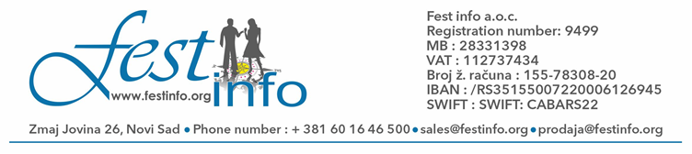

We invite you to come on
XVIII. International Folklore Festival in Italy-Rimini from
12.09 - 15.09.2024.
Participants are ensembles from Italy, Slovenia, Poland, Ukraine, Greece, Turkey, Serbia, Indonesia, India, Bosnia and Hercegovina, Croatia, Czech, Slovakia, Romania, Russia, Armenia, Lithuania, Latvia, Bulgaria, Hungary…

12.09. – Arrival of ensemble at hotel, accomodation...Info-appointment...Tour and introduction to the most popular summer resort in Italy, walking, swimming, tour of Rimini, his beautiful sun beaches, the city... Return to hotel. Dinner. Overnight stay. Possibility of departure to some of many discoteques in Rimini.

13.09. – Breakfast. Facultative half day tour to San Marino, on arrival follows a tour of this oldest republic in the world: monument of Garibaldi, Porta San Francesco, Square of freedom… Return to Rimini. Dinner. Facultative: mutually– friendly night at Discoteque… Overnight stay.

14.09. – Breakfast. Festival day ! Preparing for Defile. Defile thru the City of Rimini.
Perform of cultural-art societies. Receiving of certificates and Plaquas. Dinner. Facultative: Discoteque. Overnight stay.

15.09. – Breakfast. After breakfast departure of ensemble on facultative tour to Venice, Verona, Padova or Treiste…Return to the point of departure… With another meeting next year!!!!!!!

Price of registration fee is

125 EUROS
(paying goes in several month payments till departure time)

The arrangment price includes:
- Hotel accomodation with three stars Hotel“s like Sombrero ***, Diamond***, Tamanco***, Lily ***, Morfeo ***, Marabello ***, Picador ***, La Torretta Bramante ***, ABC Hotel***, Stacolli***, Apis***, Madrid*** ... in Rimini based on 3 half board service: breakfast and dinner in 1/3 and 1/4 rooms, supplement for 1/2 rooms is 5 e per person, per night
- Organization expenses
- Degrees
- Program leading
- Professional assistance
- Inviting letter
- Additional seat on every 25 member

The arrangment price doesn't include:
- Tourist tax for hotels in Rimini is from 2.5 € depend of Hotel chategory per person per day ( only for persons older than 16 year old )
- Facultative tours (tour of San Marino 20 €, ( 10 € with own bus ) ,Venice 25 € ( 15 € with own bus ), Bologna 15 € ( with own bus 10 €) Diskoteque 10 – 15 €, - the price of tour depends exclusively on number of interested to some of the tours
- Additional day ( half board ) is from 35 € depends from Hotel
- Visa and insurance (for cultural-art societies visas are free with inviting letter which gets every ensemble from Italian cultural-art society which also takes part in this manifestation)
ADDITIONAL INFORMATION:
thru Application on our web page : www.festinfo.org
or on email: prodaja@festinfo.org
Note: all ensembles must provide their own music, leading orchestar or music CD s. Each ensemble is obligated to set a performance in duartion of 10 – 15 minutes.
NUMBER OF SEATS IS LIMITED!!!!!!!

